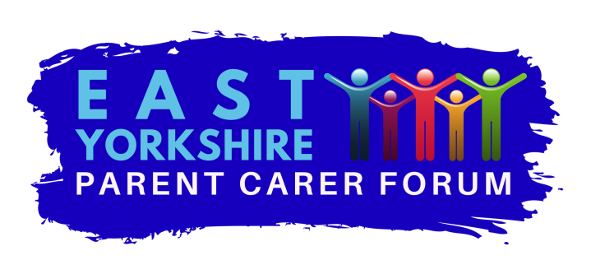
Charity number 117499
Volunteer Policy
- Who are we?
We are a group of parents and carers who are the voice of disabled children and those with additional needs across the East Riding of Yorkshire.
We engage with parents and carers across the East Riding to understand what matters to them. We try to improve understanding of disability among decision makers, identify gaps in service, influence polices and services for the benefit of parents/carers and their families.
This policy lays out the principles and practice of volunteering for EYPCF.
- What do we do?
We work by talking and listening to a wide range of parents/carers across East Yorkshire to obtain their views and ideas. We provide opportunities for parents/carers to meet together and share ideas in a relaxed environment.
We build co productive partnerships with education, health, social care and the voluntary sector to ensure parents/carers views influence services as they are designed and delivered.
- Why do we need volunteers?
The parent carer forum is completely run by volunteers apart from some administration support. The success of our work and the influence we can have for parents/carers is dependent on our dedicated team of volunteers. As the EYPCF goes from strength to strength requests are increasing for parent carer involvement extending beyond our current capacity. EYPCF is aware that there are many very capable parent carer volunteer representatives willing to help represent the views of parents/carers
It is vital that any parent carer who does provide representation on behalf of EYPCF is able to represent the views of a wide range of families in East Yorkshire. The expectations of parent representatives are that they do not represent the needs, wishes and views of their own family and should not refer to or seek to promote their own child or young person, personal, religious or political aims or own organisation. EYPCF volunteers represent the organisation and they are accountable to the EYPCF board of trustees who endeavour to ensure that policies and procedures reflect the primary aim of better outcomes for families.
- Recruiting
We are committed to offering a flexible range of opportunities and to encouraging a diversity of people to volunteer with us.
If individuals feel that they wish to volunteer, they may wish to discuss it with a trustee or member of the steering group. If they feel they would be willing to volunteer or to represent EYPCF locally or at regional or national events, then we would encourage parents/ carers to submit an expression of interest to EYPCF via email to admin@eypcf.co.uk. Contact will then be made to discuss the role and complete a volunteer form. The form would gather your information and what role you would like to have with us.
- Induction and training
All volunteers will have a 3 month trial period. This will allow volunteers to ensure they are happy with the volunteering opportunity and the EYPCF to ensure all volunteers understand and promote the principles and values of the EYPCF. Induction training will be given. This may be face to face or remotely by phone or internet eg skype. It will cover the values and principles of the EYPCF, what is expected of volunteers, basic information on EYPCF polices especially on Data protection and confidentiality and code of conduct, claiming expenses, who to raise concerns with etc. After the induction training the volunteer will be expected to sign the volunteer agreement.
Normally it is the policy of EYPCF to send 2 representatives to all meetings whenever possible. All volunteers who attend meetings for the EYPCF will be supported to do so by another more experienced volunteer. This means normally the experienced volunteer attends with the new member on the first occasion. In exceptional circumstances where this is not possible the experienced volunteer will supply the new member with all relevant information and explain it to them face to face or by phone. The chair of the meeting will be informed and expected to ensure they introduce the new member to the rest of the meeting. No new volunteer will be expected to attend a meeting they feel unprepared for.
- Expenses
EYPCF recognises that there may be some expenses to volunteering for us. In recognition of this, reasonable expenses can be claimed to enable its members and representatives who attend specified meetings and groups and carry our work as agreed by the trustee board of the EYPCF.
- Travel to and from the place of the EYPCF activity
- Travel whilst on agreed EYPCF business
- Meals taken during EYPCF activity (not alcohol)
- Replacement care of dependants including children
All claims must on the agreed form and approved by the treasurer. See the Expense policy and procedures for more detail.

- Expectations
The volunteer role is based on trust and mutual understanding. There is no enforceable obligation, contractual or otherwise, for the volunteer to attend or to undertake particular tasks or for the organisation to provide continuing opportunities for voluntary involvement, provision of training or benefits.

However, there is a presumption of mutual support and reliability. Reciprocal expectations are acknowledged – both of what the organisation expects of volunteers and what volunteers expect of the organisation.

The organisation expects volunteers:

- to be reliable and honest
- to uphold the organisation’s values and comply with organisational policies
- to make the most of opportunities given, eg for training
- to contribute positively to the aims of the organisation and avoid bringing the organisation into disrepute
- to carry out tasks within agreed guidelines

Volunteers can expect:

- to have clear information about what is and is not expected of them
- to receive adequate support and training
- to volunteer in a safe environment
- to be treated with respect and in a non-discriminatory manner
- to receive out of pocket expenses
- to have opportunities for personal development
- to be recognised and appreciated
- to be able to say ‘no’ to anything which they consider to be unrealistic or unreasonable or unprepared
- to know what to do if something goes wrong

- Confidentiality, data protection and code of conduct

All volunteers will be made aware of these polices during induction and will be required to sign a data protection agreement.

- Dealing with problems

EYPCF aims to treat all volunteers fairly, objectively and consistently. It seeks to ensure that volunteers' views are heard, noted and acted upon promptly.

We will attempt to deal with any problems at the earliest opportunity. Please contact the chair of Trustees in the event of any concerns. Your concern will be investigated by a member of the board of trustees or member acting on the trustees behalf and outcomes reported to you as soon as possible. The board of trustees decision will be final.

Volunteers will be made aware of the organisation’s complaints policy and how to use it. They will also be made aware of how inappropriate behaviour by volunteers will be addressed by the organisation.

- Leaving EYPCF

All volunteers are free to cease volunteering at anytime. It is helpful to continuity if a period of notice can be given. When a volunteer ceases their role within EYPCF whenever possible they will be encouraged to feedback and thanked for their contribution. Occasionally it maybe necessary for EYPCF to terminate a volunteer role and reasons for this will be clearly explained.

Trustees approved date………………………………..

Policy Review Oct 2020

