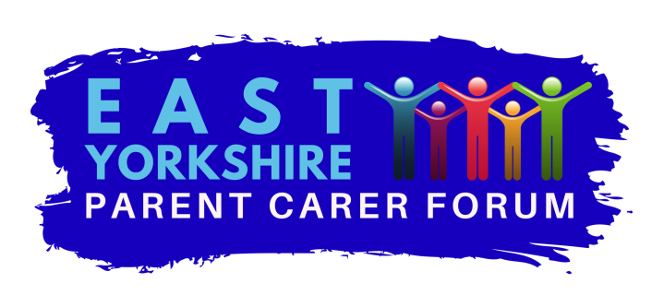
Charity number 117499
East Yorkshire Parent Carer Forum

COMMUNICATIONS /SOCIAL MEDIA POLICY

- Introduction
An essential part of the work of the EYPCF is the ability to communicate effectively, efficiently and transparently with the Trustees, steering group members, parents/carers, young adults, other organisations and a range of professionals. At the EYPCF we encourage open communication and for our members to promote the work of the EYPCF and share their passion. How we communicate reflects on us as individuals but also on the organisation as a whole.

- Scope
This policy covers all trustees, steering group members, ambassadors, volunteers and members.
It covers all forms of communication: verbal, written, email, texts and social media ( this list is not exhaustive)

- General Principles
All the EYPCF communications must be professional, sensible, appropriate, not open to misinterpretation and lawful.
All personal information relating to our members and our business operations is confidential and care must be taken to respect this confidentiality in line with the GDPR regulation 2018.

- Important guidelines to remember
In order to avoid problems and misunderstandings below are a guidelines to support and inform your communications when representing the EYPCF:

- Be aware of the code of conduct, confidentiality policy and GDPR policy at all times.
- If you post any content to the internet, written, vocal or visual which identifies you or could identify you as a member of the EYPCF then the EYPCF expects you to conduct yourself professionally according to the ethos of the organisation and respect confidentiality at all times.
- If you discuss your work or volunteering for the EYPCF or its business the EYPCF expects you conduct yourself professionally and respect the confidentiality of the data of the EYPCF.
- You are personally responsible for any information you may post on social media, blogs or web sites. When posting on the EYPCF facebook be aware of the rules (see appendix 1)Please remember the internet never forgets and what you post may be around for a long time. Use common sense if it doesn’t feel quite right then it probably isn’t. Please ask the co chairs for advice.
- Always be careful what personal information you post about yourself.
- If you have your own website or blogg or intend to create one which may indicate in any way you are a member of the EYPCF you need to report this to the co chairs and refer to the conflict of interest policy. If you identify as a member of the EYPCF on your personal website or blogg then this must be accompanied by a disclaimer such as ‘The postings on this site are my own and do not necessarily represent the position, strategy or opinions of EYPCF.’
- If you think that something on a blogg or a website could give rise to a conflict of interest or an issue of impartiality or confidentiality this must be discussed with the co chairs.
- If you receive contact from the media or the press about your online publications or for any other reason you should not respond before discussing the response with the co chairs.
- Always respect confidentiality and be aware of the GDPR. If something is marked private and confidential it is not for sharing outside the agreed group. You should never reveal personal information about members or even discuss people anonymously. Business plans, financial information and internal discussions are all confidential. If you are in doubt don’t post and discuss with the co chairs.
- Embrace diversity when posting. EYPCF will not tolerate discrimination (including age, sex, race, colour, creed, religion, ethnicity, sexual orientation, gender identity, national origin, citizenship, disability, or marital status or any other legally recognized conditions.
- Always be respectful of the EYPCF and its reputation and do not criticise or cause embarrassment. If you have a comment or complaint to make then please use the comments and complaints procedure to address it. If it concerns bullying or harassment please see the bullying/harassment policy
- Be lawful. Many aspects of communication are protected by intellectual property rights which are infringed by copying. You could be breaking copyright by downloading, uploading, posting, processing and distributing some material from the internet. If in doubt check.
- Never post in haste, take time to think, use your common sense and don’t post without advice if you are not sure.

- Relevant policies
Code of conduct
Confidentiality
GDPR
Conflict of interest
Comments and complaints
Bullying and harassment.

Approved by trustees…………………………..date

Review date Oct 2020

Appendix 1 Rules of EYPCF facebook group.

Rule 1 Respect everyone’s privacy

Being part of this group requires mutual trust. Authentic, expressive discussions make groups great, but this may also be sensitive and private. What is shared in the group should stay in the group.

Rule 2 No hate speech or bullying

Make sure everyone feels safe. Bullying of any kind isn’t allowed, and degrading comments about such things as race, religion, culture, sexual orientation, gender or identity will not be tolerated.

Rule 3 Be kind and courteous

We are all in this together to create a welcoming environment. Lets treat everyone with respect. Healthy debates are natural, but kindness is required.

