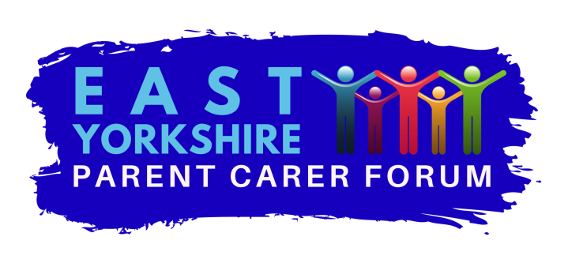
Charity number 117499
Role Description for volunteers of steering group member
THIS IS NOT A JOB DESCRIPTION AND DOES NOT FORM PART OF A CONTRACT OF EMPLOYMENT.
The parent carer forum is completely run by volunteers apart from some administration support. The success of our work and the influence we can have for parents/carers is dependent on our dedicated team of volunteers.
- What is the steering group?
This is really the powerhouse of the forum and sits under the board of trustees and carries out the day to day running of the charity. The trustees set the general direction of travel but the steering group carries this out in detail and seeks approval from the trustees when necessary. The steering group has its own chair and meets monthly except in August.
- What might you do as steering group member?
There are lots of exciting volunteering opportunities as a steering group member. The amount of time you are prepared to commit is up to you. Below are some of the things you could choose to be involved in as a steering group member. You will never be asked to do anything you do not feel confident about and there will always be support available.
- Talking and networking with other parents.
- Help organising and attending parent/carer events or coffee drop ins with speakers.
- Attend meetings with our partners in health and/or local authority to represent parent views, identify gaps in services and develop new services.
- Represent the EYPCF at meetings of the regional or national parent carer forums
- Help develop surveys and consultations to gather members’ views.
- Join the Information Group to ensure parents/carers get clear, concise and helpful information about services that is jargon free.
- Help with funding application and support the treasurer in the role.
- Help with recording meetings, spreadsheets, and publicity and presentation design.
- Give presentations to promote the work of the EYPCF.
- Talk to people on phone, dealing with incoming queries from parents/carers and answering emails.

- What do we expect from you?
- To attend as many steering group meeting as possible. These are monthly except August lasting 2 hours usually in Beverley. Travel expenses are paid.
- To contribute ideas, views and suggestions at meetings.
- To respect confidentiality of the work of the EYPCF as well as personal confidentiality of members.
- To uphold the core values of the EYPCF and represent all parents and carers and not your own child or organisation.
- To be aware of the importance of safeguarding children and vulnerable adults.
- To attend any meetings you have agreed to attend or communicate your absence to the chair and try to arrange cover.
- To report back in any form agreed by the steering group about the meetings you have attended or work you are doing for the EYPCF.
- To complete any work or planning you have agreed to do.
- We expect you to make an active contribution in a way that works for you and supports the EYPCF.

- Where will I be volunteering?
Our steering group meetings take place in Beverley and our office is currently in Bridlington but EYPCF covers the whole of the East Riding. This means we hold meetings, training sessions and drop ins for parents and carers all over the area. The meetings with the Local Authority and Health usually take place in Beverley at the council offices or at Willerby at the Health service offices.
- Expenses
In general, reasonable costs will be reimbursed that are incurred as a direct result of the EYPCF activity:
- Travel to and from the place of the EYPCF activity
- Travel whilst on agreed EYPCF business
- Meals taken during EYPCF activity (not alcohol)
- Replacement care of dependants including children.

- Do you need any qualifications?
You do not need any qualifications to volunteer with us. You need an interest in SEND perhaps with a child, grandchild or relative with SEND or experience in the SEND sector. You do not need to have detailed knowledge of SEND as you will learn this as you volunteer. You do need enthusiasm, willingness to learn, keenness to network and engage with parents/carers to make a difference.
If you do have any special skills that you feel could support our work such as IT, communication, PR, HR then please tell us about them.
- Support and policies
The EYPCF has full range of polices which you will be made aware of at your induction. This includes a volunteer policy that explains how we support our volunteers.
- How will my volunteering make a difference?
EYPCF runs entirely on volunteers except for a small amount of paid admin support. With our volunteers support on the steering group we can :
- Reach out to more parents and carers with children with SEND and make their voice heard
- Empower more parents/carers with the knowledge to get the very best support and resources for their child.
- Ensure gaps in services are identified and new services to meet the needs of parents/carers are commissioned.
- Gather the views, feelings and ideas from parents/carers
- Ensure that parents/carers are represented on all relevant meetings where their voice should be heard.
- Really make a difference for families with children and young people with a disability.

- How will I benefit?

Volunteering with us has many benefits for you.
- Opportunity to network with other parents/carers, make new friends.
- Learn a range of new skills
- Improve your own knowledge of SEND and services to benefit your family
- Build your confidence
- Improve your future job prospects.
- More importantly to have fun!
Role Description created Sept 2019

